| Test 2, Version D Name: | |
| --- | --- |
| Course Information: Phys 2A | Instructor Name: John R. Walkup |

***d*** = ***v***o*t* + (1/2)***a****t*2 ***v*** = ***v***o + ***a****t*  ***F***net = *m****a*** ***F***g = *m***g** *F*fr ≤ s*N*  *F*fr = k*N*

Use *g* = 10 m/s2 *WC = –*PE *WNC =* E *Wnet =* 😐E *W* = *Fd*cos     😐  *mv*2 PE = *mgh*

*s* = *r* *v* = *r* *a*t = *r* *a*c = *v*2/*r* net = *I*   = o + *t*  = o*t* + (1/2)*t*2 ** = *Fr* sin  

### Multiple-Choice Questions

1. According to Dr. Walkup, the key to solving equations involving forces and Newton’s second law is to:
2. First draw a picture of the system
3. Draw a free-body diagram of the system
4. Find the least-action of the system
5. Find the acceleration of the system
6. I throw a ball upwards. Which of the following is a true statement?
7. At the top of its climb, its velocity will go to 0.
8. At the top of its climb, its acceleration will go to 0.
9. Both A and B.
10. Neither A nor B.
11. An elevator descends at a constant velocity. Which of the following is true?
12. The total energy of the elevator is conserved because no net external force acts on the elevator.
13. The total energy of the elevator is conserved because the energy of any system is always conserved.
14. The total energy of the elevator is not conserved because a net external force acts on the elevator.
15. The total energy of the elevator is not conserved because a non-conservative force does work on it.
16. I lower an object of mass 7 kg (initially at rest) vertically downwards by *h* = 3 meters while applying a upward force of *F*N = 20 newtons. Which of the following collections of work-energy results is correct?
17. E = + 60 J PE = – 210 J KE = + 150 J
18. E = 0 J PE = – 60 J KE = + 60 J
19. E = 150 J PE = + 210 J KE = – 60 J
20. E = – 60 J PE = – 210 J KE = + 150 J
21. E = – 360 J PE = – 210 J KE = – 150 J
22. The mechanical energy of a system is conserved when
23. There is no net external force acting on the system
24. The objects in the system are undergoing an elastic collision
25. No non-conservative forces do work on the system.
26. Both B and C.
27. Both A and B.
28. The moon orbits the earth at a constant spin rate of 1 revolution per month. The dominant acceleration featured in this system is:
29. Angular velocity 
30. Velocity *v*
31. Tangential acceleration *a*t
32. Radial (centripetal) acceleration *a*r
33. Angular acceleration 
34. 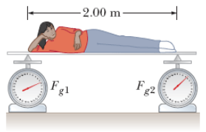Sometimes we must determine the location of a person's center of mass. This can be done with the arrangement shown in the figure. A light plank rests on two scales that read *F*g1 = 390 N and *F*g2 = 290 N. The scales are separated by a distance of 2.00 m. How far from the woman's feet is her center of mass?
35. 1.10 meters
36. 1.15 meters
37. 1.20 meters
38. 0.84 meters
39. 1.25 meters

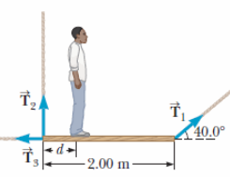

1. A uniform plank of length 2.00 m and mass 27.0 kg is supported by three ropes, as indicated by the blue vectors in the figure below. Find the tension *T*1 when a 695–N person is *d* = 0.500 m from the left end.
2. 412 newtons
3. 567 newtons
4. 476 newtons
5. 522 newtons
6. 498 newtons
7. A bicycle tire is spinning clockwise at 3.80 rad/s. During a time period of *t* = 2.35 s, the tire is stopped and spun in the opposite (counterclockwise) direction, also at 3.80 rad/s. Calculate the tire's average angular acceleration.
8. 7.63 rad/s2
9. 5.43 rad/s2
10. 2.53 rad/s2
11. 4.03 rad/s2
12. 3.43 rad/s2
13. A bicycle wheel of radius 0.2 meters is initially at rest. A torque is applied that causes it to angular accelerate at +3 rad/s2. Four seconds later, how fast is a point on the rim of the wheel traveling through space?
14. 2.4 m/s
15. 1.9 m/s
16. 12 m/s
17. 8.4 m/s
18. 6.0 m/s
19. A projectile is launched horizontally with an initial speed of 20 m/s. After 4 seconds, how far away is the object from its initial starting point?
20. 96 meters
21. 74 meters
22. 113 meters
23. 68 meters
24. 102 meters
25. A bicycle wheel is spinning at a constant rate of 20 revolutions per second. Which of the following is true about the bicycle wheel? (NOTE: Centripetal and radial accelerations are the same thing.)
26. There is no centripetal, angular, or tangential acceleration in this system.
27. It has zero centripetal acceleration, but nonzero angular and tangential acceleration.
28. It has nonzero centripetal, angular, and tangential acceleration.
29. It has zero angular and tangential acceleration, but nonzero centripetal acceleration.
30. It has zero angular acceleration, but nonzero tangential and centripetal acceleration.
31. A brick of mass 2 kg is attached to a rope of length 50 cm and whirled in a vertical circle. We will assume that the rotational rate of the brick is 3 radians per second. When the brick is at the bottom of its motion, how much tension is there in the rope?
32. 56 newtons
33. 20 newtons
34. 4.5 newtons
35. 11 newtons
36. 29 newtons

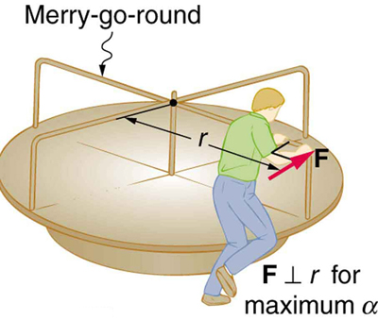

1. A 400-kg merry-go-round is acted on by a man pushing with a force *F* = 50 newtons on its perimeter, as shown in the figure. The merry-go-round has a radius of 2 meters and its moment of inertia about the axis shown is *I*A = 200 kg m2. If the merry-go-round was initially spinning at 1 rad/s, how many revolutions will it undergo after the first 4 seconds?
2. 4.0
3. 1.3
4. 8.0
5. 50.2
6. 6.0
7. How long does it take an automobile traveling in the left lane of a highway at 60.0 km/h to overtake (become even with) another car that is traveling in the right lane at 20.0 km/h when the cars' front bumpers are initially 130 m apart? (There are 3,600 seconds in an hour.)
8. 11.7 s
9. 12.9 s
10. 9.3 s
11. 16.7 s
12. 8.7 s

| Test 2, Version A Name: | |
| --- | --- |
| Course Information: Phys 2A | Instructor Name: John R. Walkup |

***d*** = ***v***o*t* + (1/2)***a****t*2 ***v*** = ***v***o + ***a****t*  ***F***net = *m****a*** ***F***g = *m***g** *F*fr ≤ s*N*  *F*fr = k*N*

Use *g* = 10 m/s2 *WC = –*PE *WNC =* E *Wnet =* 😐E *W* = *Fd*cos     😐  *mv*2 PE = *mgh*

*s* = *r* *v* = *r* *a*t = *r* *a*c = *v*2/*r* net = *I*   = o + *t*  = o*t* + (1/2)*t*2 ** = *Fr* sin  

### Show All Work and Circle Your Answer

1. In the figure, *M* = 4 kg and *m* = 2 kg. The mass *m* is at a height *H* = 3 meters above the ground. If the mass is released starting at rest, it takes 12 seconds for it to reach the ground.
2. 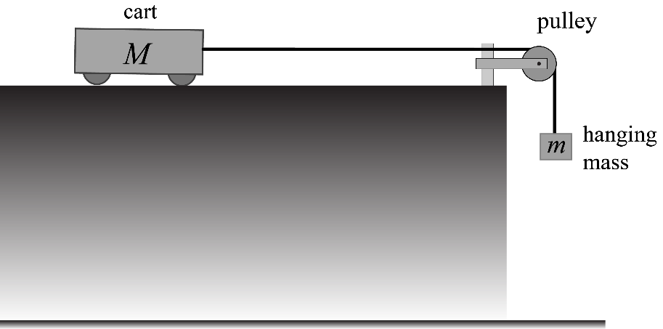What is the key physical property you must find to answer questions related to this problem?
3. What are two ways of finding this key property?
4. To find the tension is there in the string, which of the two ways in (b) will work?
5. Go ahead and find the tension in the string.
6. What is the force of friction acting on cart M?
7. What is the coefficient of friction between the cart and the table top?

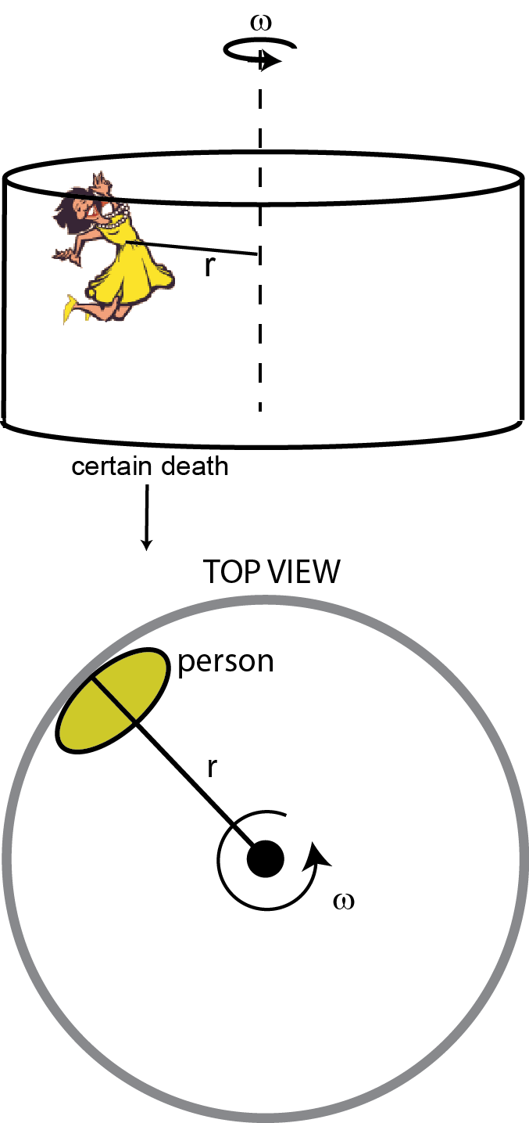

1. The Gravitron is an amusement ride that is a large steel cylinder spinning at a constant rate about its vertical axis. People stand up against the inside wall of the cylinder while it spins. Friction between their backs and the wall keep them from sliding down.

In this particular ride, the radius of the Gravitron is 5 m. It turns out that engineers expect the coefficient of static friction between the people and the walls to be at least 0.10.

1. What is the key physical property you must find to answer questions related to this problem?
2. What are two ways of finding this key property?

In a moment, I will want you to calculate the minimum angular speed necessary to keep the person from sliding down the sides of the Gravitron wall.

1. Which of the two ways in (b) will work?
2. Go ahead and calculate the minimum angular speed (in revolutions per second) necessary to keep the person from sliding down the sides of the Gravitron wall. (Use g = 10 m/s2.)

*NOTE: Do NOT simply insert numerical values into a canned formula derived specifically for this problem. You will little or no credit if you do.*

1. A car of mass 800 kg is traveling 20 m/s when the driver applies the brakes, which lock the wheels. The car skids for 5 seconds before coming to rest.
2. What is the key physical property you must find to answer questions related to this problem?
3. What are two ways of finding this key property?
4. I want you to find the coefficient of friction between the wheels and the road. Which of the two ways in (b) will work?
5. Go ahead and find the coefficient of friction between the wheels and the road
6. How far did the car travel during this time?
7. 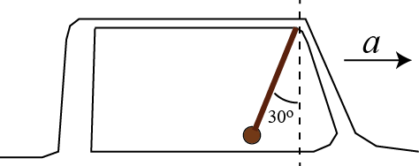A race car accelerates from rest. Because of this acceleration, an ornament hanging from the rear-view mirror forms an angle  = 30o with respect to the vertical, as shown.
8. Knowing this angle, how fast will the dragster be traveling after 10 seconds?
9. How much tension is in the string if the mass of the object is 3 kg?